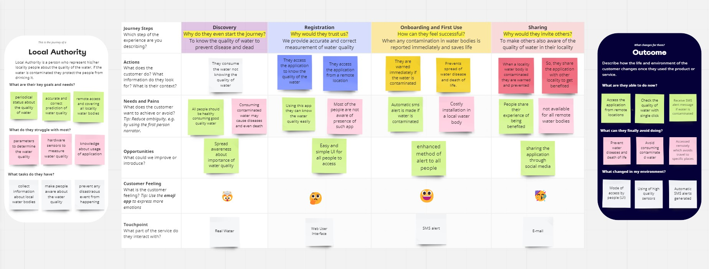Customer Journey Map

|  |  |
| --- | --- |
| Date | 18 October 2022 |
| Team ID | PNT2022TMID31051 |
| Project Name | Project - IOT Based Real-time River Water Quality Monitoring and Control System |
| Maximum Marks |  |